Insights about Mandrid City

Insight – 1:

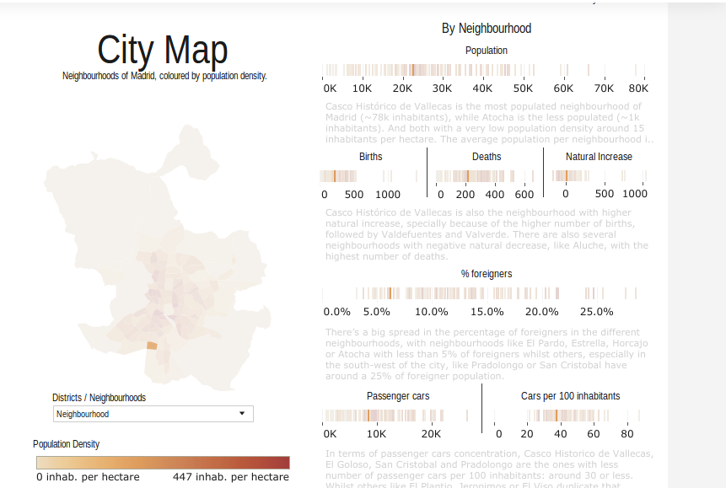
Orcasitas, a neighbourhood city of Mandrid, has a population density of around 164 inhabitants pe hectare, i.e, almost nearer to half the highest population density. When I clicked on Orcasitas on the map, we get the following details. The city is with approximately 23k population. But the city has almost no natural increase as it has almost equal number of births and deaths. Also the city is with low spread of foreigner population. In terms of passenger car concentration the city has moderate amount of concentration with 40 passenger cars per 100 inhabinants.

Insight – 2:

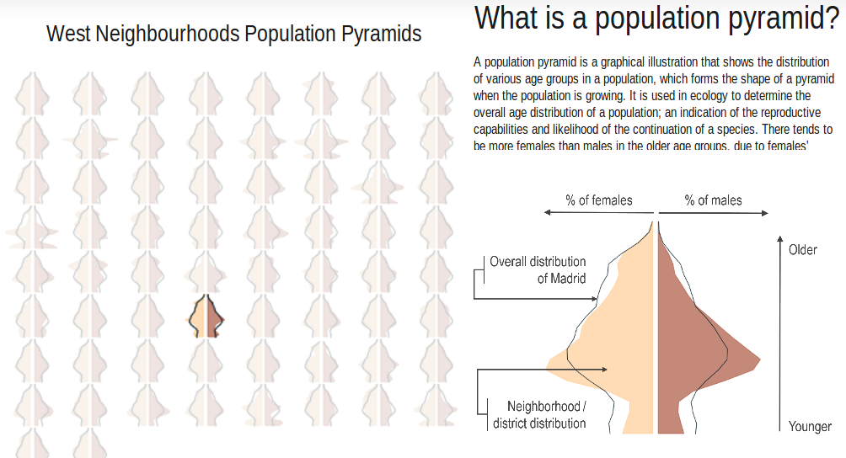
When we look at the population pyramid, there seems to be a slight female domination over males.

Insight – 3:

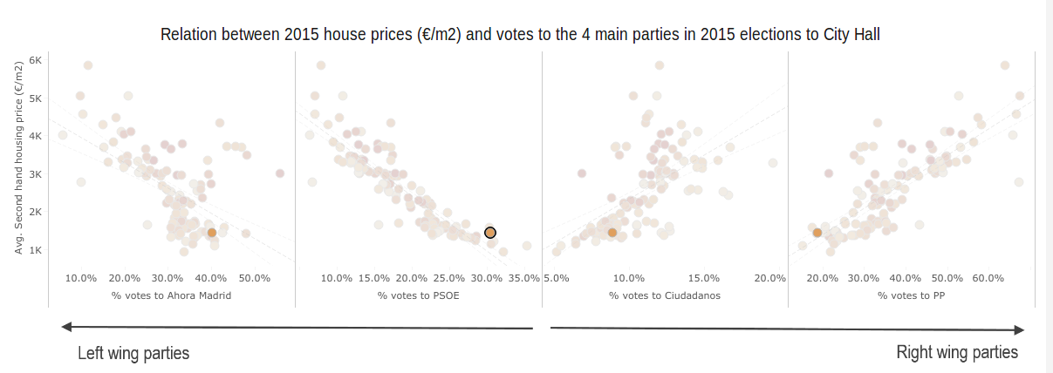
This is a graphical representation between second hand housing price during 2015 and percentage of people favourable to each party in 2015 elections. Since I clicked on Orcasitas city, we can observe that the second has housing price during 2015 in here was approximately 1,431 €/m² and most of the population (~40%) seems to be favourable to vote for Ahora Mandrid party.

